Azure Data Mapper with Files from CoPilot

Asking the AI

Coding in VS Code

Input XML and JSON files were provided…plus here is the requirements:

I was able to upload the input and output XML schema

Showing the initial code pane:

Upon initial connect, it shows here the repeating

Now it looks like this

Look at the Map Checker

Save the simple mapping

Let us see if LML and XSLT files were generated

Generated the XSLT

Now create a new map for the testing of JSON files and schema

Nice!

Asked the AI

🡪 problem solved!

Now it is good!

Code View

🡪 LML and XSLT files are now generated!!

Test Map now!

Looking great!

Reporting a bug in VS code for the Azure Data Mapper

[New Issue](https://github.com/microsoft/vscode/issues/new?template=bug_report.md)

🡪 [New Issue](https://github.com/microsoft/vscode/issues/new?template=bug_report.md)

Buggy! I need to delete the XSD in the drop down list to move further

Source

Now it is direct mapping with Array

Finally!

Test the map

Save and then generate XSLT

Test

Success! 🡺 next is to broadcast this in GitHub and linkedIn





Error on ls-a

I was able to add and commit all the files in the VS Code workspace. Now what is next for them to be added in the my personal GitHub?



Added this repo

[constantdd6/AzureDataMapper: coding journey with Azure Data Mapper inside the Logic Apps](https://github.com/constantdd6/AzureDataMapper)

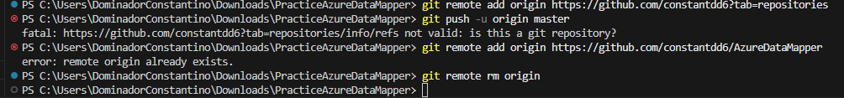

WOW! Congratulations! I have placed my code in GitHub repo

Look at my GitHub account

[Comparing main...master · constantdd6/AzureDataMapper](https://github.com/constantdd6/AzureDataMapper/compare/master?expand=1)

When clicked on Split

Okay! “main” and “master” are different

Look at the master branch

Now, the next challenge is on how to create a README file!

